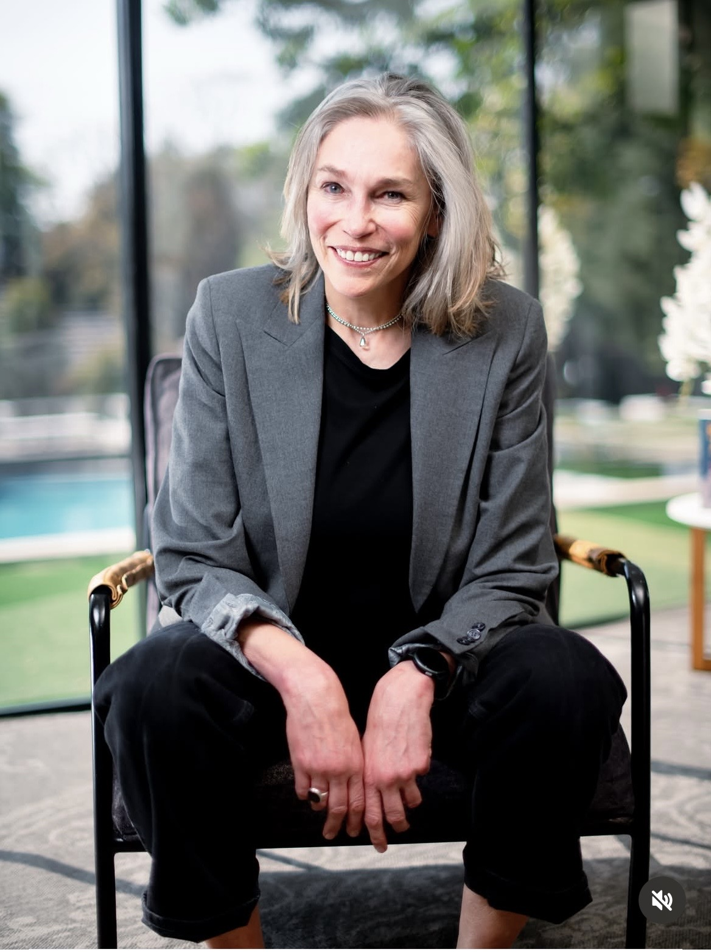
DALE HEFER
Entrepreneur | Business Builder | Marketer | Bestselling Author | Speaker
Speaker Submission Pack
Prepared for The Speakers Firm

Short Bio
Dale Hefer is a South African entrepreneur, business builder, marketer and bestselling author.
She founded ChilliBush Communications from a Johannesburg garage and built it into one of South Africa's leading independent advertising agencies, billing more than R100 million annually before selling it in 2014. She was named Businesswoman of the Year and was a finalist in the Ernst & Young Global Emerging Entrepreneur Awards.
Today she owns and runs the Nedbank IMC, Africa's Biggest Marketing Conference™.
Dale is the author of two bestselling books and speaks on goal setting, motivation, entrepreneurship and practical marketing, using the often unexpected stories behind her own business and life experience. These include how a blow-up doll once helped her business.
She is also an artist whose work sells internationally and a single mother of twins, and she has completed the Comrades Marathon, Two Oceans Marathon and Cape Town Cycle Tour.

Extended Bio
Dale Hefer has spent much of her life starting things, fixing things and occasionally selling them.
In 1998, she founded ChilliBush Communications from a Johannesburg garage. Over the following sixteen years, she built it into one of South Africa's leading independent advertising agencies, billing more than R100 million annually by the time she sold the business in 2014.
Her entrepreneurial career earned her recognition as Businesswoman of the Year and as a finalist in the Ernst & Young Global Emerging Entrepreneur Awards. ChilliBush was also named FM AdFocus Small Agency of the Year during her leadership.
Today Dale owns and runs the Nedbank IMC, Africa's Biggest Marketing Conference™. Under her leadership, the conference has grown into a major African marketing platform bringing together thousands of marketers, business leaders and industry voices from across the continent and beyond.
Her speaking draws on the much broader experience behind her books, businesses, motherhood, endurance sport and the many things she has built, sold, renovated, attempted and learnt from along the way. That includes buying and restoring properties, among them the former Johannesburg Catholic Bishop's residence, complete with the old nunnery at the back.
Her first book, From Witblits to Vuvuzelas: Marketing in the New South Africa, stripped marketing back to practical fundamentals and became recommended reading at Wits Business School. It focused on the things businesses actually need to get right: understanding customers, setting clear objectives, differentiating themselves, testing ideas, measuring results and changing what is not working.
Her second bestseller, Hustling, Happiness and a Blow-Up Doll Named Percy, is more personal, drawing on entrepreneurship, ambition, goal setting, persistence, failure and the strange situations life produces along the way. These include business highs and lows, property adventures, unlikely encounters, how a blow-up doll once helped her business, and possibly being the only person to have had a Deputy President's knees flashed at her.
Those themes remain central to Dale's speaking. She talks about why some goals turn into action while others remain intentions, what keeps people going when motivation disappears, what building a business really demands, and why simple marketing fundamentals still matter.
Her perspective comes from experience: winning and losing clients, managing cash flow, employing people, making mistakes, scaling businesses, selling them and starting again.
Dale is also an artist whose original works and prints sell locally and internationally.
She has maintained a strong commitment to youth development and community upliftment through opportunities created around the IMC and through her personal support of grassroots initiatives focused on young people.
She is a single mother of twins and has completed the Comrades Marathon, Two Oceans Marathon and Cape Town Cycle Tour.
On stage, Dale combines practical ideas with candid storytelling and humour. She is interested in what works, what does not, and what it actually takes to get things done.

Speaking Topics and Keynote Descriptions

1. Every Business Needs a Blow-Up Doll Called Percy
Unexpected lessons in resourcefulness, persistence and getting things done when the plan goes sideways.
Drawn from Hustling, Happiness and a Blow-Up Doll Named Percy, this is Dale at her most anecdotal. The stories include how a blow-up doll unexpectedly helped her business, why she may be the only person to have had a South African Deputy President's knees flashed at her, property adventures, business scrapes and other unlikely situations that turned out to contain useful lessons.
Underneath the stories is a practical point: business and life rarely unfold neatly. Resourcefulness matters. Persistence matters. Knowing when to improvise matters. And sometimes the thing that saves the day is not remotely what you expected.
Best suited to: general business audiences, women's forums, sales teams, staff conferences, entrepreneur groups and audiences that want substance without solemnity.

2. Yes, USP Is Still a Thing
Marketing basics for a world that has become very good at making marketing sound more complicated than it is.
Built on From Witblits to Vuvuzelas: Marketing in the New South Africa. Some people in the room may genuinely no longer know what USP stands for. That's funny, but it also immediately establishes the argument.
The talk covers the fundamentals businesses keep skipping: what exactly are you selling, to whom, why should they choose you, what do you want them to do, what is genuinely different about you, what worked, what didn't, and what are you measuring?
It is not anti-AI, anti-digital or nostalgic. Quite the opposite. It argues that new tools become far more useful once the underlying thinking is sound.
Best suited to: marketers, SMEs, entrepreneurs, brand teams, sales and marketing teams, business schools and anyone who suspects the basics may have been buried under a mountain of terminology.

3. Proudly Imperfect™
How painting outside the lines became permission to try things before they were perfect.
This is not really an art talk. The art is the doorway. Proudly Imperfect™ began with Dale's work, but the philosophy reaches into business, motherhood, starting again, taking risks and learning to tolerate the fact that not everything worthwhile begins beautifully.
There's a commercial twist too: imperfection didn't stop the work from selling. The thing that might once have looked like a weakness became part of the identity of the work, and ultimately something worth trademarking. What if the thing you keep trying to correct is actually part of what makes you distinctive?
For women's audiences, there's another layer around the pressure to be competent, polished, in control and effortless, all at once.
Best suited to: women's groups, creative industries, entrepreneurs, leadership teams, people facing change, and audiences who have become very good at postponing things until they feel ready.

4. I Had No Idea What I Was Doing. I Did It Anyway.
What happens when you commit before confidence catches up.
Dale has started and sold a business, acquired and grown another, renovated properties, written books, raised twins, run endurance events and become an artist, often without a neat roadmap for any of it.
This talk is about beginnings. Not the polished retrospective version where every decision looks intentional, but the point before the evidence arrives, when you're making the call without knowing exactly how it will turn out.
The stories range from starting ChilliBush from a Johannesburg garage, to taking on properties she had never renovated before, writing books without first deciding she was an author, acquiring the IMC, and later becoming an artist.
The argument is not that expertise doesn't matter. It's that expertise is often built after commitment. Confidence can follow action. Experience can be acquired. And sometimes the most important decision is being willing to begin before you have every answer.
Best suited to: entrepreneurs, women's groups, emerging leaders, younger business audiences, people starting something new, and organisations trying to encourage initiative and ownership.

5. Marketing Is Business®
Marketing works better when it stops talking mainly to itself.
Dale has seen marketing from several angles: building and selling an agency, advising clients, writing about the discipline, and now owning and running Africa's Biggest Marketing Conference™.
The argument is simple. Marketing cannot afford to become so absorbed in channels, campaigns, jargon and internal industry debates that it loses sight of customers and business outcomes. This isn't about diminishing creativity. It's about reconnecting good marketing with what the business is actually trying to achieve.
Best suited to: CMOs, senior marketing teams, agencies, executive groups, industry conferences and businesses trying to reconnect marketing activity with commercial purpose.

Executive Summary
Entrepreneur | Business Builder | Marketer | Bestselling Author | Speaker
Dale Hefer is a South African entrepreneur best known for founding and building ChilliBush Communications and for owning and running the Nedbank IMC, Africa's Biggest Marketing Conference™.
Current
CEO and Owner, IMC Academy (Pty) Ltd, which owns and runs the Nedbank IMC, Africa's Biggest Marketing Conference™.
The Nedbank IMC attracts marketers, business leaders and industry voices from across Africa and internationally.
Entrepreneurial Career
ChilliBush Communications | Founder and CEO | 1998–2014
- Founded from a Johannesburg garage in 1998.
- Built into one of South Africa's leading independent advertising agencies.
- Annual billings exceeded R100 million by the time Dale sold the business in 2014.
- Worked across major South African and multinational brands during the agency's growth.
- Won FM AdFocus Small Agency of the Year and Adweek South Africa Small Agency of the Year during Dale's leadership.
Nedbank IMC
- Dale acquired the IMC and subsequently relaunched and grew it into the Nedbank IMC.
- Today it is Africa's Biggest Marketing Conference™, with thousands of delegates and participants from across the continent and beyond.
- The platform is built around Dale's broader philosophy, Marketing is Business®.
Awards and Recognition
- Businesswoman of the Year
- Finalist, Ernst & Young Global Emerging Entrepreneur Awards
- FM AdFocus Small Agency of the Year, ChilliBush Communications
- Adweek South Africa Small Agency of the Year, ChilliBush Communications
Author
From Witblits to Vuvuzelas: Marketing in the New South Africa
- A practical guide to marketing in the South African context.
- Became recommended reading at Wits Business School.
Hustling, Happiness and a Blow-Up Doll Named Percy
- A bestselling collection of business, life and entrepreneurial stories dealing with ambition, persistence, resourcefulness and the unexpected lessons behind building a life and career.
- Both books achieved bestseller status.
Speaking
Dale speaks on business, entrepreneurship, marketing, action, persistence and the often unexpected lessons behind building things.
Current signature talks include:
- Every Business Needs a Blow-Up Doll Called Percy
- Yes, USP Is Still a Thing
- Proudly Imperfect™
- I Had No Idea What I Was Doing. I Did It Anyway.
- Marketing is Business®
Her speaking style combines practical ideas, anecdotal storytelling and humour.
Art
Dale is an artist whose original works and prints sell in South Africa and internationally.
Her art is produced under Proudly Imperfect™, a philosophy and creative platform built around individuality, imperfection and creative confidence.
Youth and Community
Dale has a longstanding commitment to youth development and industry access.
Through the Nedbank IMC and related initiatives, she has supported opportunities for students and young marketers to gain exposure to the marketing industry, senior business leaders and professional networks.
She also personally supports grassroots youth initiatives, including Seeds of Kindness.
Personal
- Single mother of twins.
- Completed the Comrades Marathon, Two Oceans Marathon and Cape Town Cycle Tour.
- Has also bought, renovated and sold a number of properties, including the former Johannesburg Catholic Bishop's residence and its adjoining nunnery.
Education
BA, English and Afrikaans
University of Natal, Pietermaritzburg
1984–1986
Trademarks / Proprietary Platforms
- Marketing is Business®
- Proudly Imperfect™
- Shift Happens™
- Africa's Biggest Marketing Conference™
- Heartspeak®
Websites and Links
Dale Hefer website: dalehefer.com
LinkedIn: za.linkedin.com/in/dale-hefer-a57607122
Nedbank IMC: marketingisbusiness.africa
Professional Speaking Fee
To be discussed and agreed with The Speakers Firm based on format, audience, location and scope.
Technical Rider
Wireless handheld or lapel microphone, standard stage lighting and access to venue AV if required. Dale is comfortable presenting with or without slides.
Travel and Accommodation Preferences
Dale is happy to travel locally and internationally. Travel and accommodation arrangements can be discussed according to the location and requirements of each engagement.

MC Welcome
Please welcome Dale Hefer, South African entrepreneur, business builder, marketer and bestselling author. Dale founded ChilliBush Communications from a Johannesburg garage and built it into an agency billing more than R100 million annually before selling it in 2014. Today she owns and runs the Nedbank IMC, Africa's Biggest Marketing Conference™.
She is also the author of two bestselling books, an artist, a single mother of twins, and someone who has completed the Comrades Marathon, Two Oceans Marathon and Cape Town Cycle Tour.
Her talks are practical, candid and often unexpected. Depending on the subject, you may hear how a blow-up doll once helped her business, or why she believes the basics still matter.
Please welcome Dale Hefer.

Books

From Witblits to Vuvuzelas: Marketing in the New South Africa
Penguin / Oshun Books, 2010
Bestselling practical marketing book focused on the South African market. It became recommended reading at Wits Business School.
Selected reviews:
- “There is something special about reading an uncompromisingly South African book that could take its place with the best of its genre on international bookshelves.” — Sunday Times
- “A landmark in South African marketing.” — Victor Dlamini
- “Done the industry a service.” — Andy Rice
- “Well worth the read.” — Jeremy Maggs
Book information

Hustling, Happiness and a Blow-Up Doll Named Percy
Jonathan Ball Publishers, 2021
A bestselling collection of business, life and entrepreneurial stories dealing with ambition, persistence, resourcefulness and the unexpected lessons behind building a life and career.
Publisher
Goodreads
Amazon

Selected Articles and Thought Leadership
Shift Happens. Are You Ready? — Bizcommunity
Dale Hefer: The year marketers need to get more from less — Bizcommunity
Starting a R100 million ad agency from her garage — Modern Marketing
How resilience becomes a leadership discipline — Modern Marketing
Marketing Gets Naked: It's About the Bottom Line — The Media Online
Bringing Marketing to the Boardroom Table — Business Day
A Story of Reinvention, Resilience and Leadership — South African Business Matters

Selected Video, Speaking and Panel Appearances
GIBS panel discussion — includes the original Percy story and a discussion on creativity, business and practical marketing
The Lead Creative with Mongezi Mtati — building communities, relevance, business, marketing fundamentals and the growth of the Nedbank IMC
Business of Influence Podcast
Pat on Brands
OneAfrica / Namibia interview
Nedbank IMC presentation
Nedbank IMC 2025 highlights
The Speakers Firm also already has access to Dale's recently filmed EmpowaWorx video material.

Selected Podcast, Radio and Broadcast Appearances
Marketing is Business with Mike Stopforth
The Lead Creative
99FM Namibia
CNBC Africa: Measuring the Business of Marketing

Profile and Credibility Links
Bizcommunity profile
Dale Hefer website
Modern Marketing interview / profile
Media Update
The School of Thought

Art
Pixalot
Pictufy
International print example — Olive et Oriel

